PFD47XS Professional Development Methods
Activity on Node Networks & Calculations
Examination Answers — 27 March 2024

Question 1 — CPM Network Analysis
Node key: top row = ES | Activity | EF · bottom row = LS | Duration | LF · Blue = Critical path (TF = 0)
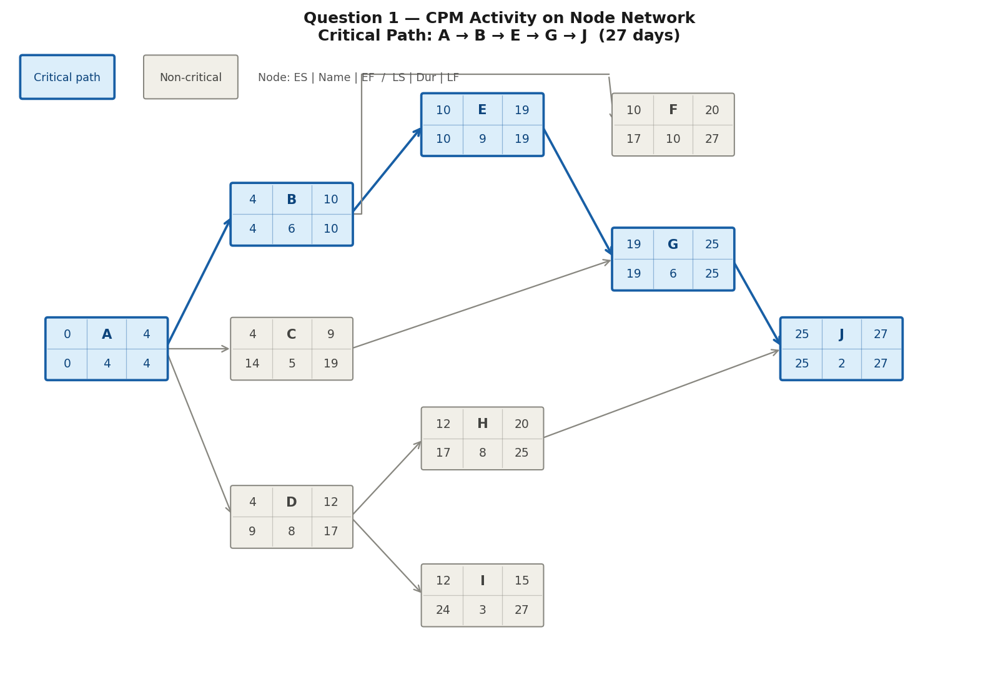

1.1 All Paths & Project Finish Time
A → B → E → G → J = 4 + 6 + 9 + 6 + 2 = 27 days ← CRITICAL PATH (longest)
A → B → F = 4 + 6 + 10 = 20 days
A → C → G → J = 4 + 5 + 6 + 2 = 17 days
A → D → H → J = 4 + 8 + 8 + 2 = 22 days
A → D → I = 4 + 8 + 3 = 15 days
Project Finish Time = 27 days

1.2 Critical Path
Critical Path: A → B → E → G → J = 27 days (all activities have Total Float = 0)

1.3 Forward Pass — Early Start (ES) and Early Finish (EF)
EF = ES + Duration ES = max(EF of all predecessors)

Act. | Dur | Pred. | ES Calculation | ES | EF
A ★ | 4 | Start | Start of project = 0 | 0 | 4
B ★ | 6 | A | EF(A) = 4 | 4 | 10
C | 5 | A | EF(A) = 4 | 4 | 9
D | 8 | A | EF(A) = 4 | 4 | 12
E ★ | 9 | B | EF(B) = 10 | 10 | 19
F | 10 | B | EF(B) = 10 | 10 | 20
H | 8 | D | EF(D) = 12 | 12 | 20
I | 3 | D | EF(D) = 12 | 12 | 15
G ★ | 6 | C, E | max(EF(C), EF(E)) = max(9, 19) = 19 | 19 | 25
J ★ | 2 | G, H | max(EF(G), EF(H)) = max(25, 20) = 25 | 25 | 27

1.4 Backward Pass — Late Finish (LF), Late Start (LS) and Total Float (TF)
LS = LF − Duration LF = min(LS of all successors) TF = LS − ES

Act. | Dur | Succ. | LF Calculation | LF | LS | TF
J ★ | 2 | End | Project end = 27 | 27 | 25 | 0
G ★ | 6 | J | LS(J) = 25 | 25 | 19 | 0
H | 8 | J | LS(J) = 25 | 25 | 17 | 5
F | 10 | End | Terminal node — project end = 27 | 27 | 17 | 7
I | 3 | End | Terminal node — project end = 27 | 27 | 24 | 12
E ★ | 9 | G | LS(G) = 19 | 19 | 10 | 0
C | 5 | G | LS(G) = 19 | 19 | 14 | 10
D | 8 | H, I | min(LS(H), LS(I)) = min(17, 24) = 17 | 17 | 9 | 5
B ★ | 6 | E, F | min(LS(E), LS(F)) = min(10, 17) = 10 | 10 | 4 | 0
A ★ | 4 | B, C, D | min(LS(B), LS(C), LS(D)) = min(4, 14, 9) = 4 | 4 | 0 | 0

★ = On the critical path (TF = 0). Activities with TF > 0 can be delayed by that amount without delaying the project.

1.5 Float Formulas
Total Float (TF) = LS − ES (or equivalently: LF − EF)
Free Float (FF) = ES(nearest successor) − EF(this activity)
Independent Float (IF) = ES(nearest successor) − LF(predecessor) − Duration

Question 2 — PERT Network Analysis
Node key: top row = ES | Activity | EF · bottom row = LS | Ceiling ED | LF · Blue = Critical path
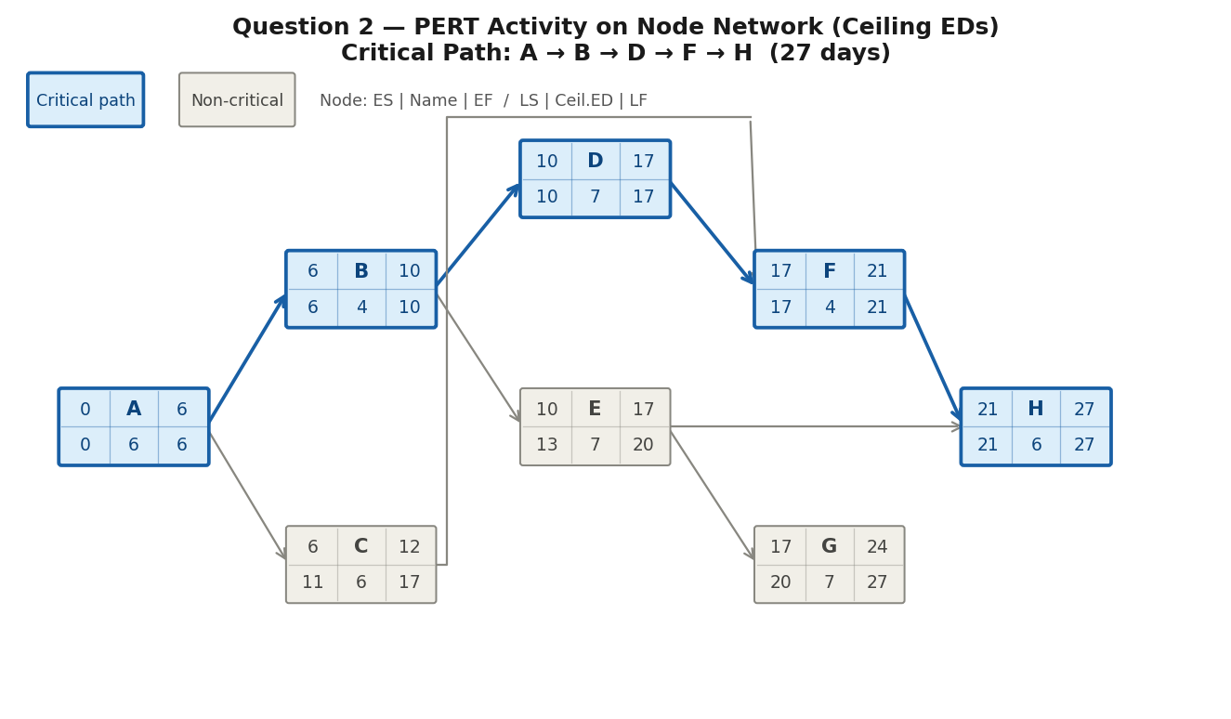

2.2 Expected Durations (Ceiling ED)
ED = (O + 4M + P) ÷ 6 Ceiling ED = round up to next whole number

Act. | O | M | P | ED = (O + 4M + P) ÷ 6 | Ceiling ED
A | 4 | 5 | 7 | (4+20+7)/6 = 5.17 | 6
B | 1 | 3 | 6 | (1+12+6)/6 = 3.17 | 4
C | 4 | 5 | 7 | (4+20+7)/6 = 5.17 | 6
D | 3 | 7 | 10 | (3+28+10)/6 = 6.83 | 7
E | 4 | 6 | 9 | (4+24+9)/6 = 6.17 | 7
F | 2 | 3 | 5 | (2+12+5)/6 = 3.17 | 4
G | 1 | 7 | 10 | (1+28+10)/6 = 6.50 | 7
H | 2 | 6 | 8 | (2+24+8)/6 = 5.67 | 6

2.2b Forward Pass (using Ceiling EDs)
EF = ES + Ceiling ED ES = max(EF of all predecessors)

Act. | Ceil.ED | Pred. | ES Calculation | ES | EF
A ★ | 6 | — | Start of project = 0 | 0 | 6
B ★ | 4 | A | EF(A) = 6 | 6 | 10
C | 6 | A | EF(A) = 6 | 6 | 12
D ★ | 7 | B | EF(B) = 10 | 10 | 17
E | 7 | B | EF(B) = 10 | 10 | 17
F ★ | 4 | C, D | max(EF(C), EF(D)) = max(12, 17) = 17 | 17 | 21
G | 7 | E | EF(E) = 17 | 17 | 24
H ★ | 6 | E, F | max(EF(E), EF(F)) = max(17, 21) = 21 | 21 | 27

All Paths
A → B → D → F → H = 6 + 4 + 7 + 4 + 6 = 27 days ← CRITICAL PATH
A → B → E → H = 6 + 4 + 7 + 6 = 23 days
A → C → F → H = 6 + 6 + 4 + 6 = 22 days
A → B → E → G = 6 + 4 + 7 + 7 = 24 days
Expected Project Finish Time = 27 days

2.3 Backward Pass
LS = LF − Ceiling ED LF = min(LS of all successors) TF = LS − ES

Act. | Ceil.ED | Succ. | LF Calculation | LF | LS | TF
H ★ | 6 | End | Terminal — project end = 27 | 27 | 21 | 0
G | 7 | End | Terminal — project end = 27 | 27 | 20 | 3
F ★ | 4 | H | LS(H) = 21 | 21 | 17 | 0
E | 7 | G, H | min(LS(G), LS(H)) = min(20, 21) = 20 | 20 | 13 | 3
D ★ | 7 | F | LS(F) = 17 | 17 | 10 | 0
C | 6 | F | LS(F) = 17 | 17 | 11 | 5
B ★ | 4 | D, E | min(LS(D), LS(E)) = min(10, 13) = 10 | 10 | 6 | 0
A ★ | 6 | B, C | min(LS(B), LS(C)) = min(6, 11) = 6 | 6 | 0 | 0

★ = Critical path (TF = 0). Critical Path: A → B → D → F → H = 27 days

2.3 Variance & Standard Deviation (Critical Path Activities)
Variance = ((P − O) ÷ 6)² σ = √(sum of variances on critical path)

Act. | O | P | (P − O) ÷ 6 | Variance
A | 4 | 7 | (7-4)/6 = 0.500 | 0.250
B | 1 | 6 | (6-1)/6 = 0.833 | 0.694
D | 3 | 10 | (10-3)/6 = 1.167 | 1.361
F | 2 | 5 | (5-2)/6 = 0.500 | 0.250
H | 2 | 8 | (8-2)/6 = 1.000 | 1.000
Total |  |  | Sum of variances on critical path (A+B+D+F+H) | 3.555

Standard Deviation: σ = √3.555 = 1.886 days

2.3 95% Confidence Finish Time
For 95% confidence: z = 1.645 (from Z-table)
x = z × σ + μ = 1.645 × 1.886 + 27 = 3.10 + 27 = 30.10 days
→ We have 95% confidence of finishing by 30.10 days

2.4 Probability of Finishing 1 Day After Expected Finish
Target date = μ + 1 = 27 + 1 = 28 days
z = (x − μ) ÷ σ = (28 − 27) ÷ 1.886 = 0.53
From Z-table: P(z ≤ 0.53) = 0.7019
→ Probability of finishing within 28 days = 70.19%

— End of Document —

